Reservation slip  (대한상부위장관 헬리코박터학회 한일심포지엄) |  | 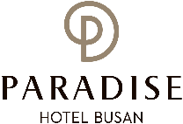
*Check In : | *Check out: | 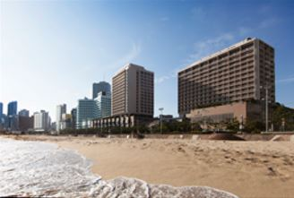  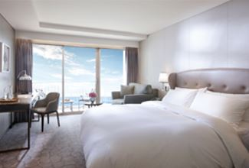  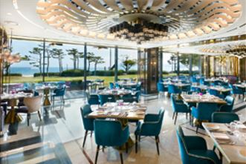  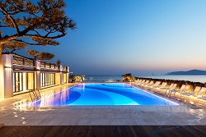
*No. of Persons:
*Last/ First Name: ☐ Mr. ☐ Ms.

*Country:
*Telephone: | *Email:
Remark :
PAYMENT
*Credit Card Type: ☐ Etc. ☐ Visa ☐ Masters ☐ Amex (4Digit-number : )
*Expiry Date:
*Credit Card Number:
*Card Holder’s Name:
ROOMS CATEGORY | SPECIAL ROOM RATE | OTHERS RATE
Deluxe City View Room | ☐ KRW 217,800 (Double Bed)  ☐ KRW 217,800 (Twin Bed) | *Breakfast  (Advance booking Discount)  ☐ KRW 35,000/ Person  *Extra Bed  ☐ KRW 72,600  *Saturday Surcharge  + Add KRW 72,600
Deluxe Ocean Side View Room | ☐ KRW 254,100 (Double Bed)
Deluxe Ocean Terrace View Room | ☐ KRW 278,300 (Double Bed)  ☐ KRW 278,300 (Twin Bed)
* The rates above are non-commissionable, and they are Inclusive of 10% Service Charge and 10% Government Tax.
* The rates above are the special rate only for symposium attendees.
* Check-in time is 3pm Check out time is 12pm ( If you pass the check out time, the following rates will apply)
Until 3pm: 50% of the room rate, After 3pm: 100% of the room rate
* Full Buffet breakfast will be served at the’ On the Plate Restaurant’ at the Main Building Lobby Floor
* Free Access : High Speed Internet Wi-fi, Fitness center, Swimming pool, Play station zone
* 50% Special Discount on admission to Sauna and Outdoor hot spring ‘Cimer’
※ Policies: Cancellation or No Show after the room reservation is being charged as below;
* From 7days to 4days prior to Arrival date : 30% of the Room charge
* From 3days to 2days prior to Arrival date : 50% of the Room charge
* From 1days or less prior to Arrival date : no refund
Please send reservation to: res@paradisehotel.co.kr or call Tel no. +82-51-749-2111-3

